Computer Language Coding Concepts

Enforcing & Preventing Specialization
The world of programming languages offers several ways to prevent or enforce specialization. This article will give this a place inside the new computer language.

The concepts from other languages can be boiled down to a simpler model that has to provide the following:

- Protected
- Overriding
- Required / Optional
- Requirements for other side of connection

Protected
The protected access connector makes sure that a member is not publically available, is privately available, but also available to all references (triangles) that merge with their container.

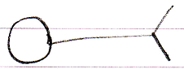
Protected Object Set

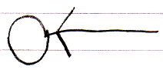
Protected Object Get

In other words: Protected will be accomplished by providing ‘public’ access through a triangle reference, but ‘private’ access through a circle reference. In the picture below the triangle offers access to the member, but the circle does not.

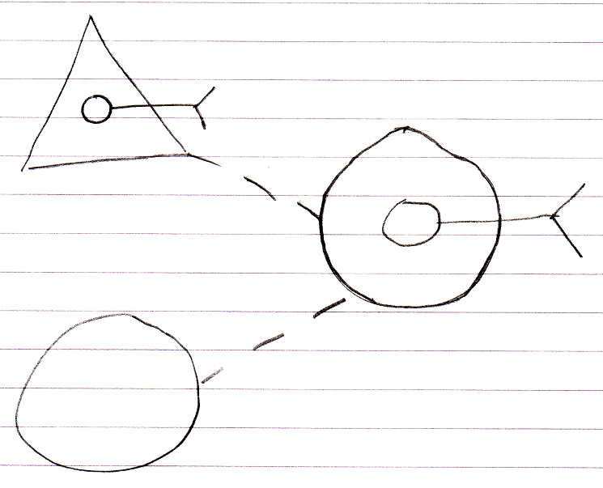

Note that Protected members are still privately accessible, which means that Friend objects can always access Protected members as well.

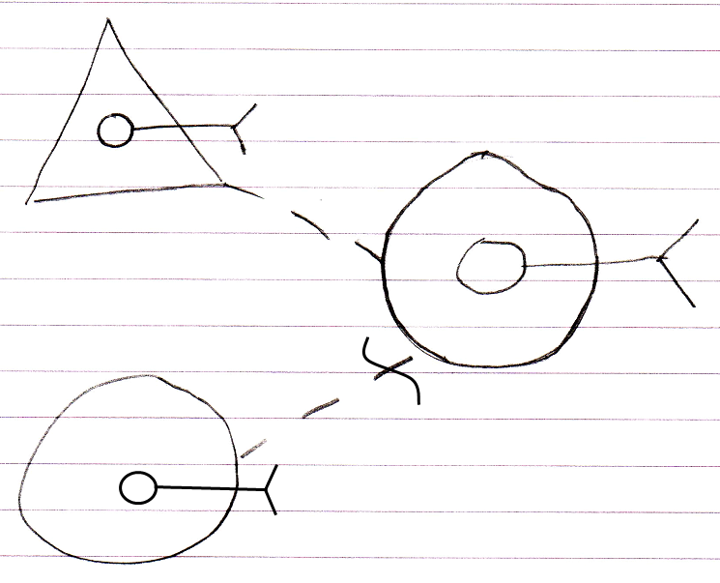

Overriding
The overriding concept is already explained in the specialization article. The notation of it is preliminary. There are the following candidate notations:

Object reference notation:

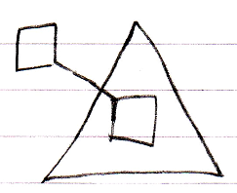

Intrinsic overriding notation:

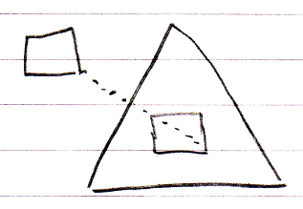

Event notation:

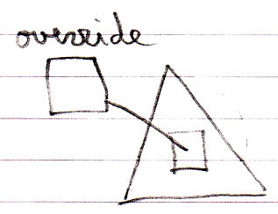

Optional / Required
The concepts from other languages for preventing or enforcing specialization require imposing requirements: some things must be filled in. The concept of required is already worked out in the article Optional & Required in a Diagram. The notation looks as follows:

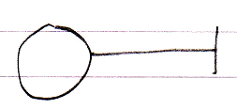
Optional
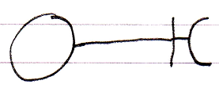
Required

Required is expresses by putting half of the expected symbol at the end of the connector. Optional does not get such a symbol, because it is the default behavior that things are optional to fill in. Required is an extra rule imposed.

Requirements for Other Side of Connection
The concepts from other languages for preventing or enforcing specialization require being able to specify that the other end of the connection needs to be a triangle. For now this is expressed as follows:

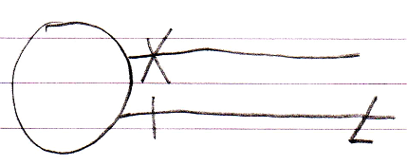

So it is a notation where the requirements for the other end of the connection are expressed at the other end of the connector. The connector line continues after the specified requirement as to not conflict with the notation for Required in general, like this:

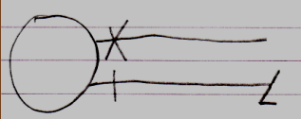

Gut Feeling
A gut feeling of mine is that Protected and requirements for other side of connection could be made more alike, because both are about how the other end must be a triangle, but in one case that the direct reference must be a triangle, and in the other case the parent must be a triangle. So these requirements for it being a triangle might have to be merged into one concept one day.

The notation come up with for requirements for the other side of the connection may be inspiration for a notation for a more elaborate security model one day.

Applied to Concepts from Other Languages
The following keywords from other languages that prevent or enforce specialization are covered along with how they translate to the new computer language:

Protected
Virtual
Abstract member
Abstract class
Sealed / Final
Interface
Interface member
Non-Overridable (the default in other languages)

Protected
For now Protected is an intrinsic part of the new computer language. It has its own type of access mark:

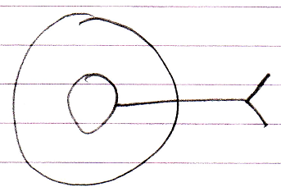
Protected

Virtual
The keyword virtual from other languages means that you can override the member. It is also called Overridable. In the new computer language this means that overriding should be Public. In the three candidate notations for overriding this would look as follows:

Object reference notation:
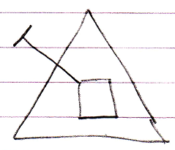
Public Object Set
Intrinsic overriding notation:
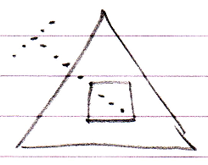
Public Override
Event notation:
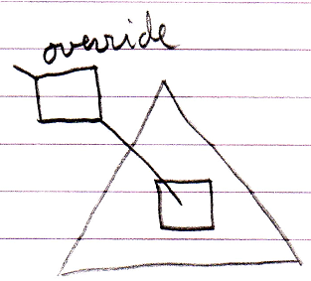
Public Object Override

In some languages overriding is private by default, protecting a base class from specialization.

Abstract Member
When the keyword abstract from other languages is applied to a member, it means that you must override the member. It is also called MustOverride. In the new computer language is a combination of making overriding Public and Required. The new computer language has three candidate notations for overriding, and in those notations an abstract member would look as follows:

Object reference notation:
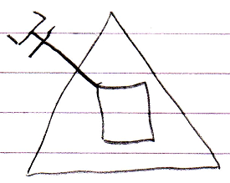
Public Required Object Set
Intrinsic overriding notation:
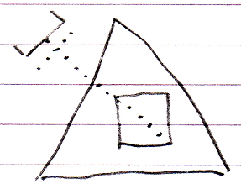
Public Required Override
Event notation:
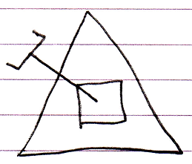
Public Required Object Override

< Forgot the word Override in the diagram. >

Abstract Class
When the keyword abstract from other languages is applied to a class, it means that you must inherit from the class, or better said: you can not just reference the class, the reference must merge with its container.

In the new computer language this gets the following preliminary notation:

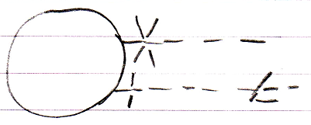

Private Use As Class
Public Triangle Use As Class

Or perhaps simply:

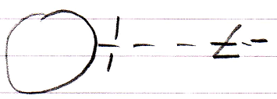

Public Triangle Use As Class

Abstract applied to a class is also called MustInherit. Do not get confused: abstract applied to a class does not mean that its commands are abstract, so must be overridden, it just means that the class must be inherited from. An abstract class can have method implementations in it.

Sealed / Final Class
The keywords sealed and final mean the same thing. A sealed class, or final class, is the opposite of an abstract class: instead of only being able to inherit from the class, you are explicitly not able to inherit from the class. It is also called NotInheritable.

In the new computer language this gets the following preliminary notation:

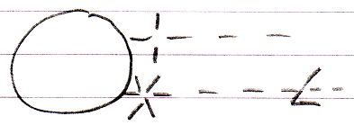

Public Use As Class
Private Triangle Use As Class

< Or simply just:
< Picture with only Private Triangle Use As Class in it. >
>

Here it becomes apparent that the notation should not be just an open half triangle, because this would imply that the connector is Required, which it explicitly is not.

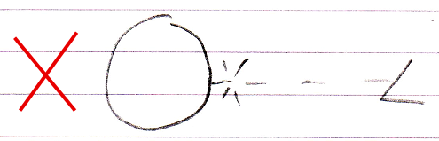

The use of this enforcement is questionnable to me, because with a little effort you could wrap a final class into an inhertitable class again. I can imagine that a final class could not have virtual or abstract members, so such a trick would not make it possible to override members after all, but it will make it possible to do any other inheritance trick in the book.

Interface (member)
In other programming languages the keyword interface is used to denote something equivalent to an abstract class with only abstract members, in other words: a class you can not instantiate, but only inherit from and each of its members must all be overridden. The the new computer language has three candidate notations for overriding, so it could be expressed in three different ways for now:

Object reference notation:
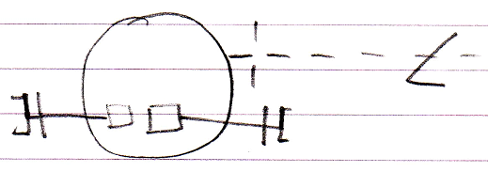
Public Triangle Use As Class
Public Required Object Set
Intrinsic overriding notation:
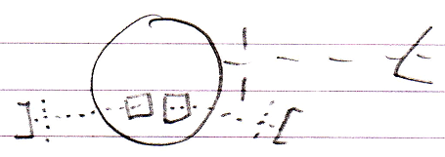
Public Triangle Use As Class
Public Required Override
Event notation:
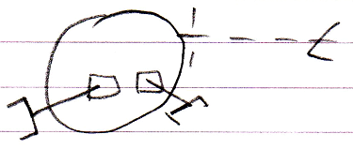
Public Triangle Use As Class
Public Required Object Override

So the pictures show a combination of the abstract class concept and the abstract member concept, which is equivalent to an interface and its interface members.

I must admit that the notation looks bad from an esthetic point of view.

The implementation above does not enforce that the interface does not have any implementations. It just is not possible yet in the new computer language to enforce that members do not specify an implementation at all or that all members will adhere to the same set of rules. It will probably be come up with later.

In the new computer language any object can be used as an interface. And using it as an interface only takes over the interface parts of the object, not the implementation.

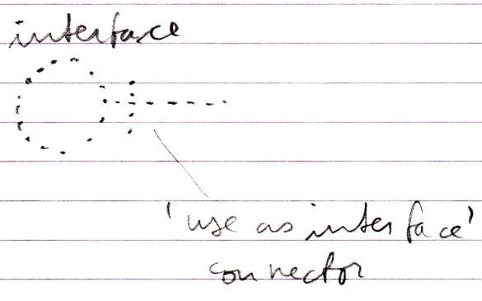

Non-Overridable
Not being able to override is the default in other languages, but in the new computer language it is an imposed restriction, making overriding Private, which looks as follows in the three candidate notations for overriding that the new computer language currently employs:

Object reference notation:
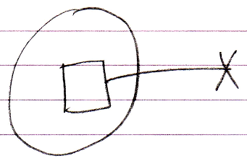
Private Object Set
Intrinsic overriding notation:
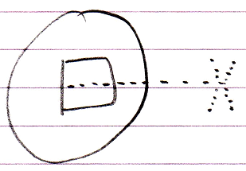
Private Override
Event notation:
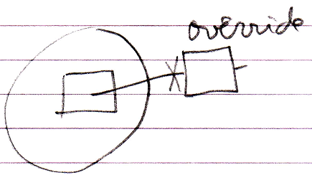
Private Object Override

Overridable Unless Specified Otherwise
If Object Set would be Public by default you could always override things, allowing you to create a totally altered system by means of inheritance.

If Object Set would be Private by default, specialization of the class would be better protected, but it would still be possible to create a totally altered system by means of inheritance when you declare another object Friend.

More Combinations
With the concepts explained so far you can form other combinations of protection against specialization. For instance the following:

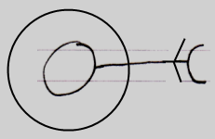

Protected Required Object Set

But in other languages this is also possible by making a member protected abstract.

Courtesy
All of this is just courtesy to support all these concepts in the new computer language. My gut feeling is that something simpler will be come up with in the future.

For instance the Protected connector notation was come up with at a very early stage, long before the other inheritance-related modifiers were considered. My gut feeling is that I have to let go of the notation for Protected and go for a notation more concise and integrated with all of the other things that can be expressed. Protected really does not deserve such an intrinsic notation compared to the rest of the inheritance-related modifiers.

This article is just put here to make sure that at least all of this stuff is possible in the new computer language, but my gut feeling is that a replacement for all of this must be found.

Enforcing & Preventing Other Specialization Methods
The ideas above will provide other language’s capabilities to enforce or prevent specialization. But what about the other specialization methods? How are they enforced or pevented? The following specialization methods were not covered:

- Altering the Member Set:

- Member Addition
- Member Exclusion
- Member Inclusion

- Detouring Members:

- Shadowing

- Altering Command Implementations:

- Command Pre- and Post-Extension
- System Command Pre- and Post-Extension
- Overriding System Commands
- Shadowing System Commands

To get it inline with the rest of the system, the following methods for protection of enforcement of specialization should become applicable to each of the specialization methods:

- Protected
- Required / Optional
- Requirements for other side of connection (for it to be a triangle)

However, these other specialization methods do not really disturb the class’s original implementation. The work required to work this all out is not done right now, because it is not considered very important.

Author & Copyright: Jan-Joost van Zon Date: May 23, 2010 – May 29, 2010 Location: Oosterhout, The Netherlands Status: Preliminary Version

